Description : This query calculates the conversion percentage for each country, helping measure campaign effectiveness.

Query :

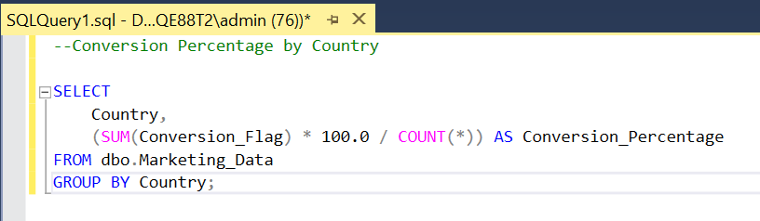

Solution :

